AWS beginner guide
Oct 9, 2026 · @Dev Bhargav
AWS (Amazon Web Services) rents you computing, storage, networking and databases by the hour or the gigabyte, so you build systems without buying hardware. This guide covers what you need to operate it: the core ideas, the services you will use most, and a 30 day plan to learn them by doing.

1. What AWS is and how it is organized
Cloud means using someone else's data centers over the internet and paying only for what you use. AWS offers over 200 services, but a beginner needs roughly twenty.
Concept | What it means | Why it matters
Account | A container for all your resources and bills | Use separate accounts for sandbox and production
Region | A geographic area with several data centers, such as Mumbai (ap-south-1) or Singapore (ap-southeast-1) | Data stays in the region you choose. Pick one close to users and check that a service exists there
Availability Zone (AZ) | One or more separate data centers inside a region, such as ap-south-1a | Spread workloads across two AZs so one failure does not take you down
Service | A product such as EC2 or S3 | Each has its own console page, API and pricing
Resource | One thing you created, such as a server or a bucket | Resources are what you pay for and what you secure
ARN | Amazon Resource Name, the unique ID of a resource | Appears in every policy and integration, for example an IAM Role ARN
Three ways to operate AWS: the Management Console (web UI, best for learning), the AWS CLI (commands, best for repeat work) and SDKs or Infrastructure as Code such as CloudFormation or Terraform (best for production).
Shared responsibility. AWS secures the data centers, hardware and the service software. You secure what you put in it: user access, firewall rules, data encryption and operating system patches on servers you run. Most real AWS breaches come from the customer side, usually a public storage bucket or a leaked access key.

2. Security first: IAM
IAM (Identity and Access Management) decides who can do what on which resource. Learn it before anything else, because every other service depends on it.
Term | Meaning
Root user | The email you signed up with. It can do everything. Enable MFA, create no access keys, and use it only for rare account tasks
IAM user | A person or program with its own sign-in. Prefer IAM Identity Center for people
Group | A set of users that share permissions
Role | An identity that a service or another account assumes temporarily. No long-lived password or key
Policy | A JSON document listing allowed or denied actions
MFA | A second sign-in factor. Turn it on for root and every human user
A minimal policy that lets someone read one S3 bucket:
{
"Version": "2012-10-17",
"Statement": [{
"Effect": "Allow",
"Action": ["s3:GetObject", "s3:ListBucket"],
"Resource": ["arn:aws:s3:::my-bucket", "arn:aws:s3:::my-bucket/*"]
}]
}
Rules to follow from day one:
- Least privilege. Grant only the actions and resources needed. Avoid "Action": "*" and "Resource": "*" unless you can justify them.
- Roles over keys. A server should use an attached role, never an access key saved in code.
- Everything is denied by default, and an explicit Deny always wins over Allow.
- Cross-account access works by a role in your account whose trust policy names the other account. This is exactly how Cisco XDR connects, using an external ID to prevent misuse.

3. Compute: where your code runs
Service | What it is | Use it when | Billing
EC2 | Virtual servers you manage fully | You need full control, a custom OS, or a long-running app | Per second while running
Lambda | Runs a function in response to an event, no server to manage | Short tasks: API backends, file processing, scheduled jobs | Per request and run time
ECS / EKS | Run containers (ECS is AWS native, EKS is Kubernetes) | You already package apps in Docker | Underlying EC2 or Fargate
Fargate | Serverless containers | You want containers without managing servers | Per CPU and memory used
Elastic Beanstalk / App Runner | Upload code and AWS runs it | Simple web apps with little setup | Underlying resources
EC2 basics to learn: instance type (size, such as t3.micro), AMI (the OS image), key pair or Session Manager for login, security group (firewall), EBS volume (disk), and Auto Scaling (adds or removes instances with load). A stopped instance stops compute charges, but its disks still cost money.

4. Storage
Service | Type | Typical use
S3 | Object storage in buckets | Backups, logs, website files, data lakes. Nearly unlimited, very durable
EBS | Block disk attached to one EC2 instance | Server operating system and databases
EFS | Shared network file system | Many servers reading the same files
Glacier (S3 storage classes) | Cheap archive | Data you rarely read, such as old logs
S3 essentials:
- Buckets have globally unique names and objects are addressed by a key, such as logs/2026/10/file.gz.
- Block Public Access should stay on at account level unless you deliberately host public content.
- Versioning keeps old copies. Lifecycle rules move or delete data automatically to cut cost.
- Storage classes trade price for retrieval speed: Standard, Standard-IA (infrequent access), Glacier Instant, Flexible and Deep Archive.
- Encryption at rest is on by default. Use KMS keys when you need to control or audit key use.
- S3 is the standard landing place for security logs, which is why XDR reads VPC Flow Logs and CloudTrail from it.

5. Networking: VPC
A VPC (Virtual Private Cloud) is your own private network inside a region. Every EC2 server, database and load balancer lives in one.
Piece | What it does
VPC | The network, defined by an address range such as 10.0.0.0/16
Subnet | A slice of the VPC in one AZ. Public subnets route to the internet, private subnets do not
Internet Gateway | Lets public subnets reach the internet and be reached
NAT Gateway | Lets private servers make outbound connections without being reachable from outside
Route table | Decides where traffic from a subnet goes
Security group | Stateful firewall on a resource. Allow rules only. Replies are allowed automatically
Network ACL | Stateless firewall on a subnet. Allow and deny rules, evaluated in order
Load balancer | Spreads traffic across servers. ALB for web (layer 7), NLB for raw TCP/UDP (layer 4)
Route 53 | DNS: turns names into addresses, with health checks and failover
CloudFront | Content delivery network that caches content near users
VPN / Direct Connect | Private links between your office or data center and the VPC
A standard layout: public subnets hold load balancers, private subnets hold application servers and databases, across two AZs. Only the load balancer faces the internet.
For security, keep servers in private subnets, open security groups only to the ports and sources you need (never 0.0.0.0/0 on SSH or RDP), and turn on VPC Flow Logs to record who talked to whom.

6. Databases and messaging
Service | Type | Choose it when
RDS | Managed relational (MySQL, PostgreSQL, SQL Server, Oracle, MariaDB) | You need SQL, joins and transactions without managing the server
Aurora | AWS relational engine, MySQL and PostgreSQL compatible | You want higher performance and faster failover than standard RDS
DynamoDB | Serverless key-value and document | Huge scale, single-digit millisecond lookups, simple access patterns
ElastiCache | In-memory cache (Redis, Valkey, Memcached) | Speeding up reads and storing sessions
Redshift | Data warehouse | Analytics over large datasets
Athena | Run SQL directly on files in S3 | Querying logs without loading a database
RDS tips: enable Multi-AZ for automatic failover, automated backups, and keep the database in a private subnet.
Messaging services connect parts of a system so they do not depend on each other directly:
- SQS: a queue. One part adds messages, another processes them at its own pace.
- SNS: publish and notify. One message fans out to email, SMS, queues or Lambda.
- EventBridge: routes events between services by rules, and runs schedules.

7. Monitoring, logging and security services
This group matters most for security work such as Cisco XDR.
Service | Answers the question | Notes
CloudWatch | How is it performing, and what did it log? | Metrics, logs, dashboards and alarms. Alarms can notify SNS
CloudTrail | Who did what in my account? | Records API calls and console actions. Management events are on for 90 days by default. Create a trail to S3 for long-term storage
VPC Flow Logs | Which IPs talked to which, on what port? | Network metadata, not packet contents. Send to S3 or CloudWatch
AWS Config | Is this resource configured to my rules? | Tracks configuration history and compliance
GuardDuty | Is something suspicious happening? | Managed threat detection using CloudTrail, flow logs and DNS logs
Security Hub | What is my overall security posture? | Collects findings from other services
Inspector | Which servers and images have vulnerabilities? | Scans EC2, containers and Lambda
KMS | Who controls the encryption keys? | Create and audit keys used by S3, RDS, EBS and others
Systems Manager | How do I manage and patch servers at scale? | Session Manager gives shell access without opening SSH
A beginner security baseline: root MFA on, a multi-region CloudTrail trail, GuardDuty enabled, S3 Block Public Access on, flow logs on the main VPC, and a billing budget alert.

8. Cost and billing: avoid surprise bills
AWS bills for what you use, with no upfront cost by default. Three models exist: On-Demand (pay as you go), Savings Plans or Reserved (commit for one or three years for a discount) and Spot (spare capacity at a large discount, can be interrupted).
Where beginners get charged unexpectedly:
- Servers or databases left running after a lab
- NAT Gateways, which charge per hour plus per GB
- Elastic IPs and EBS volumes that are no longer attached
- Data transfer out to the internet (inbound is free)
- Large CloudWatch log volumes
Protect yourself on day one:
- Open Billing > Budgets and create a monthly budget with an email alert at a low figure.
- Turn on Cost Explorer to see spend by service.
- Tag every resource, for example project=xdr-lab, so you can find and delete it.
- Delete lab resources the same day, and check every region you used.
Free usage: AWS runs a free plan for new accounts with credits and limited services. Terms change, so read the current offer on the AWS Free Tier page before relying on it.

9. Common use cases
Use case | Services typically combined
Host a website | S3 + CloudFront + Route 53 (static), or EC2 / App Runner behind an ALB (dynamic)
Web application | ALB + EC2 or Fargate in private subnets + RDS + S3
Serverless API | API Gateway + Lambda + DynamoDB
Backup and archive | S3 with lifecycle rules to Glacier
Data analytics | S3 + Glue + Athena or Redshift
Event-driven automation | EventBridge or SNS + Lambda, for example auto-remediating a risky security group
Security monitoring | CloudTrail + VPC Flow Logs + GuardDuty into S3 and a tool such as Cisco XDR
Hybrid network | Site-to-Site VPN or Direct Connect into a VPC

Service cheat sheet
Need | Start with
A server | EC2
Run code without servers | Lambda
Store files | S3
A disk for a server | EBS
A SQL database | RDS or Aurora
A NoSQL database | DynamoDB
A private network | VPC
Control access | IAM
See who did what | CloudTrail
Metrics, logs, alarms | CloudWatch
Detect threats | GuardDuty
Queue or notify | SQS or SNS
Domain names | Route 53
Encryption keys | KMS

10. A 30 day learning path
Use a fresh account, set a budget alert first, and delete each lab when done.
Week | Focus | Hands-on lab
1 | Account, IAM, regions | Create an account, enable root MFA, make an admin user in IAM Identity Center, install the AWS CLI and run aws sts get-caller-identity
2 | Storage and compute | Create an S3 bucket, upload a file, add a lifecycle rule. Launch a t3.micro EC2 instance, connect with Session Manager, then terminate it
3 | Networking and databases | Build a VPC with public and private subnets. Place an RDS database in the private subnet. Add a security group that allows only the app tier
4 | Monitoring and security | Create a multi-region CloudTrail trail to S3. Enable VPC Flow Logs to S3. Turn on GuardDuty. Build a CloudWatch alarm that emails you through SNS
After the first month, learn one Infrastructure as Code tool (CloudFormation or Terraform), then study for the AWS Certified Cloud Practitioner and Solutions Architect Associate. For a security focus, follow with Security Specialty. AWS Skill Builder and the AWS documentation provide free labs.

11. How AWS connects to Cisco XDR
The week 4 labs above are exactly the pieces XDR needs. XDR assumes an IAM role in your account, then reads VPC Flow Logs and CloudTrail from S3 to model assets and detect threats. Setup, policies and troubleshooting are in the separate AWS and Cisco XDR connectivity guide. Practice it in a sandbox account first.

Sources
- AWS documentation, docs.aws.amazon.com (service behavior and terminology, written from general knowledge, not looked up for this guide)
- Prices, free-tier terms and region lists change often. Confirm them in the AWS console before relying on them.

Appendix: a typical three-tier layout
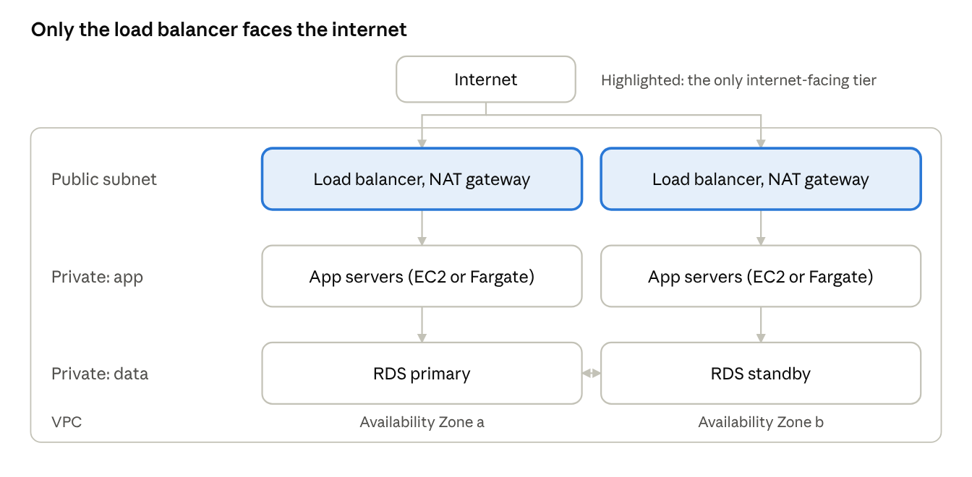
three-tier layout across two availability zones
A load balancer in public subnets takes traffic, application servers sit in private subnets, and the database runs in a primary and standby pair across two availability zones.

